

**LORAWAN PROJECT  
Wiring Diagram Hardware**

By:

Devomech Solutions Pvt. Ltd.

Date: 06-04-2023

# Field #01 Components List

* Arduino Mega 2560
* Lora Shield 915Mhz
* Mini Motor Driver
* AA Cell Holder (8 cell)
* 12v to 5v fixed Voltage Buck Converter
* Solenoid Valve

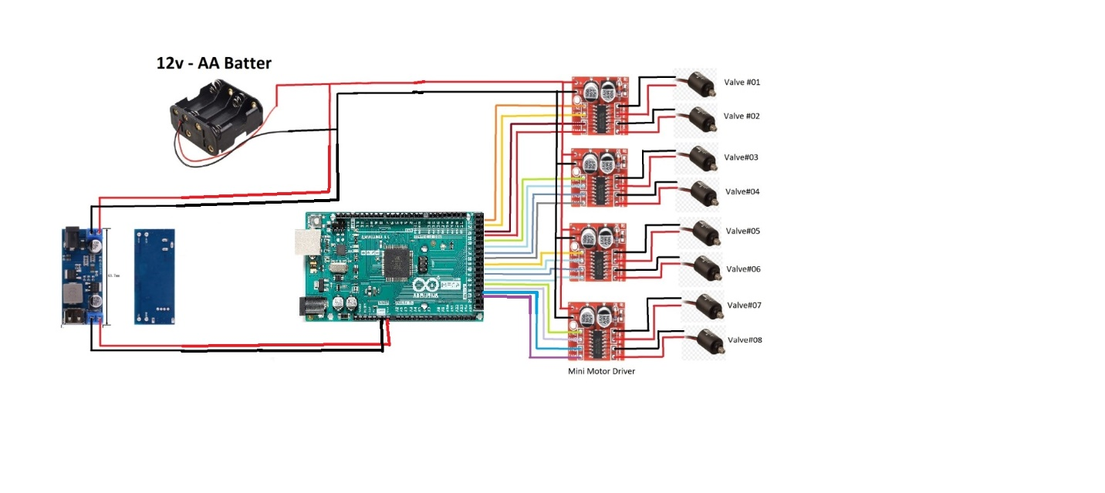

|  |  |
| --- | --- |
| Arduino Mega 2560 (GPIO Pin) | Mini Motor Driver (Field#01) |
| 23 | INT-1 |
| 25 | INT-2 |
| 27 | INT-3 |
| 29 | INT-4 |
| 31 | INT-1 |
| 33 | INT-2 |
| 35 | INT-3 |
| 37 | INT-4 |
| 39 | INT-1 |
| 41 | INT-2 |
| 43 | INT-3 |
| 45 | INT-4 |
| 47 | INT-1 |
| 49 | INT-2 |
| 51 | INT-3 |
| 53 | INT-4 |

# Field #02



|  |  |
| --- | --- |
| Arduino Mega 2560 (GPIO Pin) | Mini Motor Driver (Field #02) |
| 23 | INT-1 |
| 25 | INT-2 |
| 27 | INT-3 |
| 29 | INT-4 |
| 31 | INT-1 |
| 33 | INT-2 |
| 35 | INT-3 |
| 37 | INT-4 |
| 39 | INT-1 |
| 41 | INT-2 |
| 43 | INT-3 |
| 45 | INT-4 |
| 47 | INT-1 |
| 49 | INT-2 |
| 51 | INT-3 |
| 53 | INT-4 |

# Components List

* Irrigation Controller
* Arduino Mega 2560
* Lora Shield
* 12v to 5v fixed voltage buck converter
* 9v adapter

# House

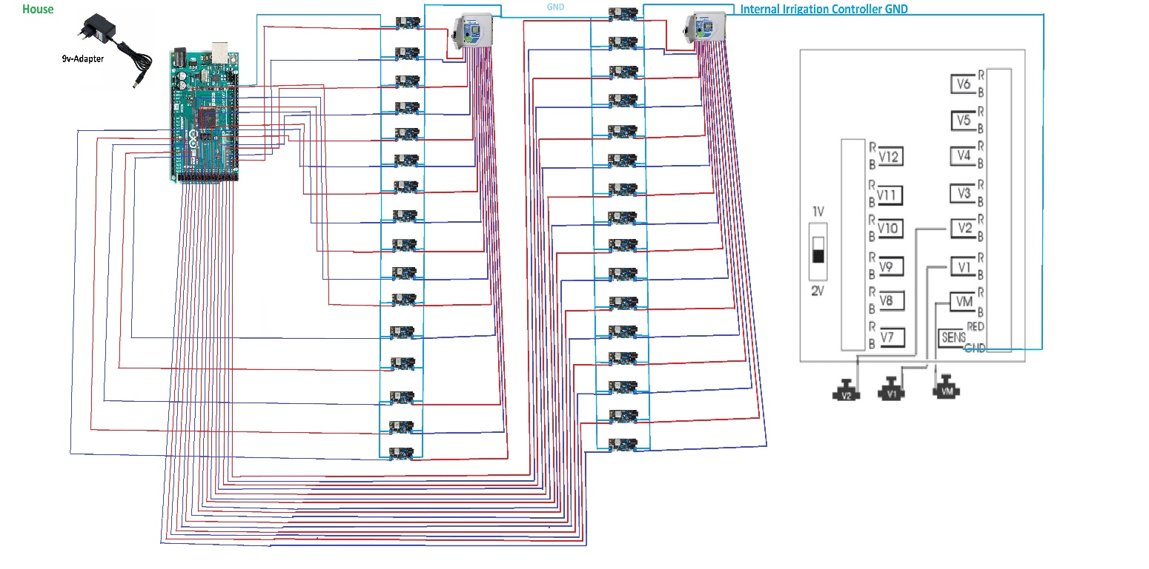

|  |  |
| --- | --- |
| Arduino Mega 2560 (GPIO Pin) | Irrigation Controller (Right) |
| 23 | VA1 |
| 25 | VB1 |
| 27 | VA2 |
| 29 | VB2 |
| 31 | VA3 |
| 33 | VB3 |
| 35 | VA4 |
| 37 | VB4 |
| 39 | VA5 |
| 41 | VB5 |
| 43 | VA6 |
| 45 | VB6 |
| 47 | VA7 |
| 49 | VB7 |
| 51 | VA8 |
| 53 | VA9 |

|  |  |
| --- | --- |
| Arduino Mega 2560 (GPIO Pin) | Irrigation Controller (Left) |
| 22 | VA1 |
| 24 | VB1 |
| 26 | VA2 |
| 28 | VB2 |
| 30 | VA3 |
| 32 | VB3 |
| 34 | VA4 |
| 36 | VB4 |
| 38 | VA5 |
| 40 | VB5 |
| 42 | VA6 |
| 44 | VB6 |
| 46 | VA7 |
| 48 | VB7 |
| 50 | VA8 |
| 52 | VA9 |